a parent’s guide to…

**Parent Consultation**

**By**

**ICT Development**

A Parent’s Guide to Parent Consultation

*Contents*

**Introduction**

**My Account**

* Children
* Change Password
* Timeslots
* My Consultations

**Our Schools**

**Booking a Consultation**

*Introduction*

* Firstly, visit <http://parentconsultation.co.uk>
* This will take you to the following page.

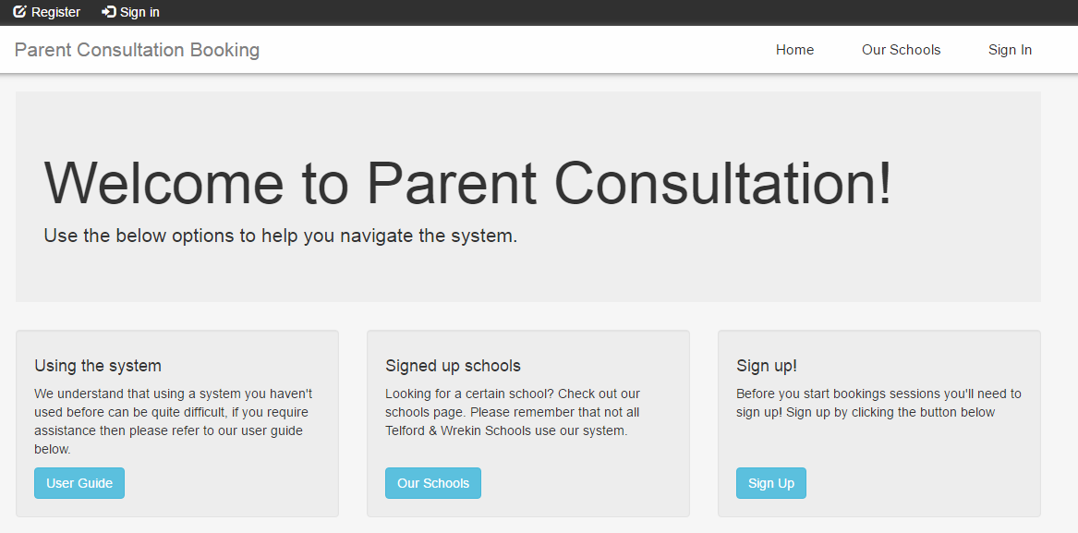

* You will then need to register an account. This can be done by using the “Register” link.

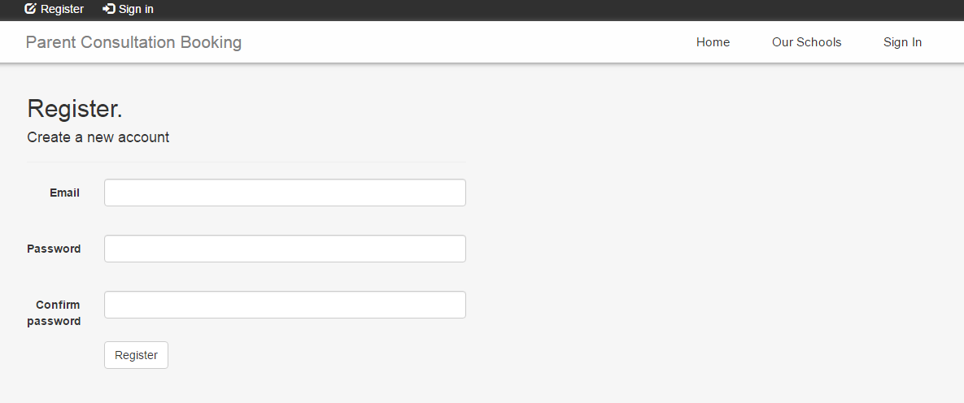  
**Password will need to contain one Uppercase character, one Lowercase character and one Special character.**

* + If you already have an account please login through the “Sign In” link.  
      
    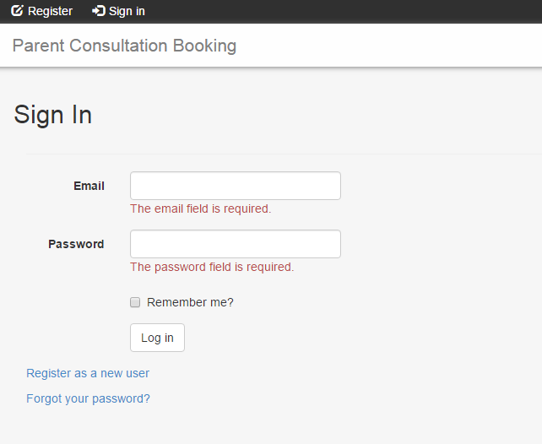
* After logging in you will be brought to the following page:  
    
  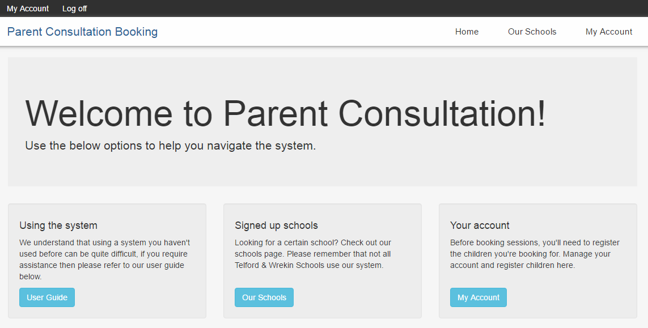

From here you will see there are multiple options to click on. These are as follows:

* User Guide will bring you to this user guide where you can learn how to use Parent Consultation.
* Our Schools will take you to the list of schools that are using the Parent Counsulation system.  
  *You will need to go here to book Consultation sessions with your desired school.*  
  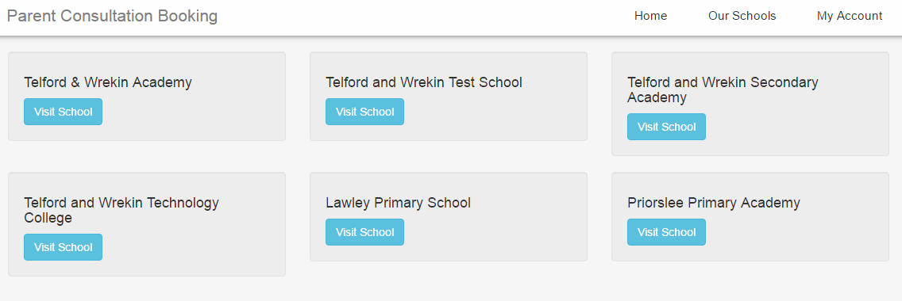
* My Account will take you to multiple options relevant to your account.  
  *You will need to go here to add a child to your account, view your Consultations, change your password and view the timeslots you have booked.*  
  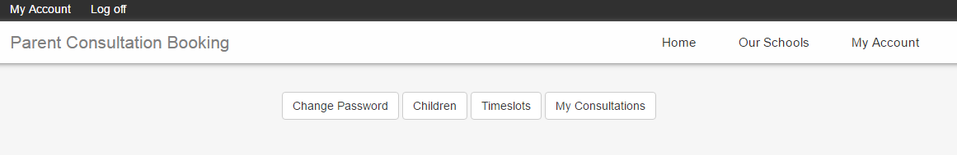
* Home will bring you back to the Parent Consultation landing page (the first page you see after logging in).

*My Account*

**Children**

* Now you are aware of a general site map the first thing you should do is go to the “My Account” page in order to add your child/children to the Parent Consultation system.
* Once on the following page, click the “Children” tab.  
    
  

* You will now see the following screen.  
    
  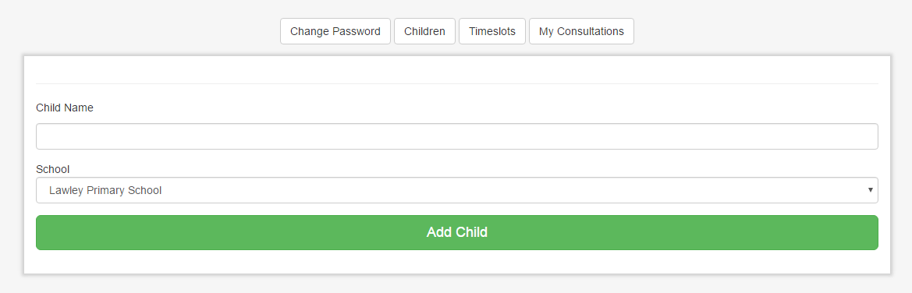

* Choose the school your child/children attend from the dropdown list. (If you have children at multiple schools you will still be able to manage the Consultations for each child through the Parent Consultation site)   
    
  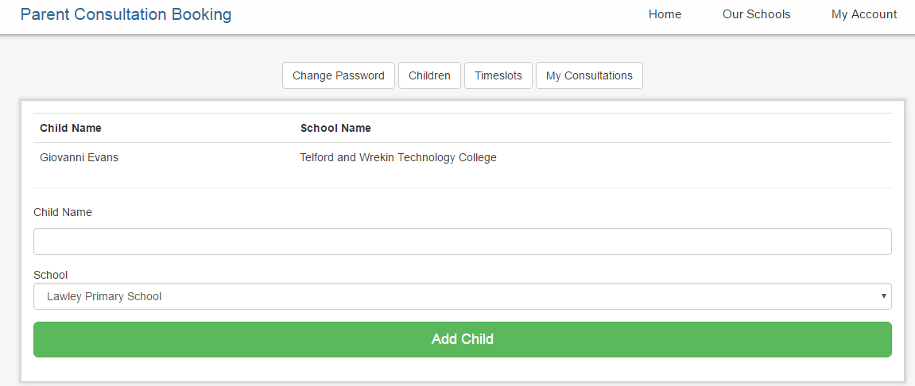
* Once you’re happy with adding children to schools you are ready to book a timeslot for your child

You will find that in the guide here.

**Change Password**

* In the “My Account” section you can also Change your Password  
    
  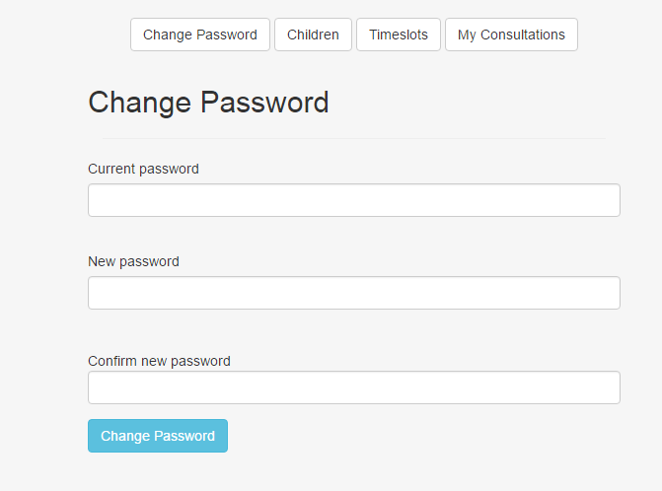

* To do this all you need to do is click on the “Change Password” tab, enter your old Password, a new Password and then confirm the new Password by inputing it again. Once you have done this click “Confirm new password” and your Password will be changed for next login.

**Timeslots**

* Timeslots will be blank until you have booked a specific time with a teacher. If you want to know how to do this please follow this link. (The “Timeslots” will look like the image below if no booking has been made).   
    
  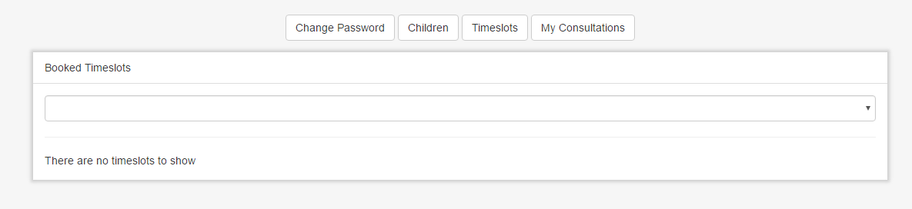

* If you have already booked you the “Timeslots” tab will look like this(if there are multiple bookings for multiple children they will show here too):  
    
  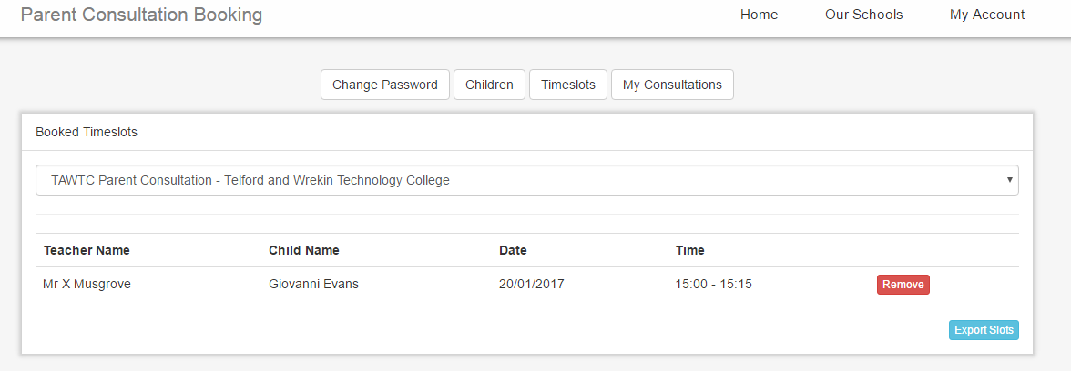
* From this view you are able to remove the booking(s) that have been made or you can click “Export Slots” which will export this view into Excel so that it can be easily printed and taken with you.

**My Consultations**

* My Consultations will show a record of any schools that you have previously booked a Consultation with.
* My Consultations will be blank until you have successfully booked a time with a teacher. For information on how to do this please follow this link. (The “My Consultations” will look like the image below if no booking has been made).   
    
  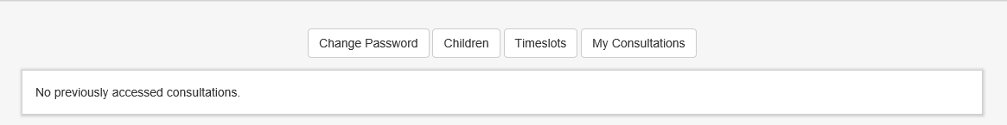
* Once signed in and booked the “My Consultations” tab will look like this:   
    
  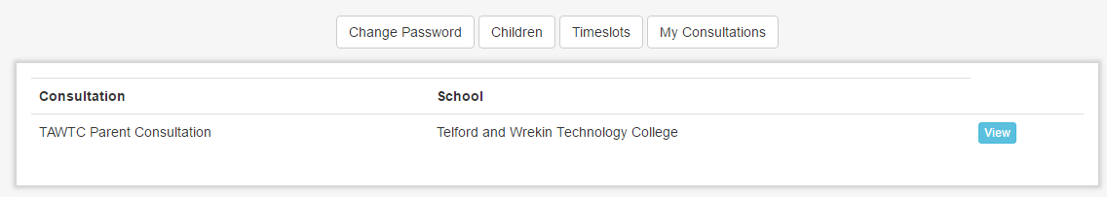

* Clicking the view button from here will take you to the “Booking” page where you can look through the teachers and book timeslots.

*Our School*

* The “Our School” site is a tab that shows the schools that have signed up to Parent Consultation.



* From here you can select the school that you are looking for by clicking the “View School”
* If you select a school you will be brought to the school page.   
    
  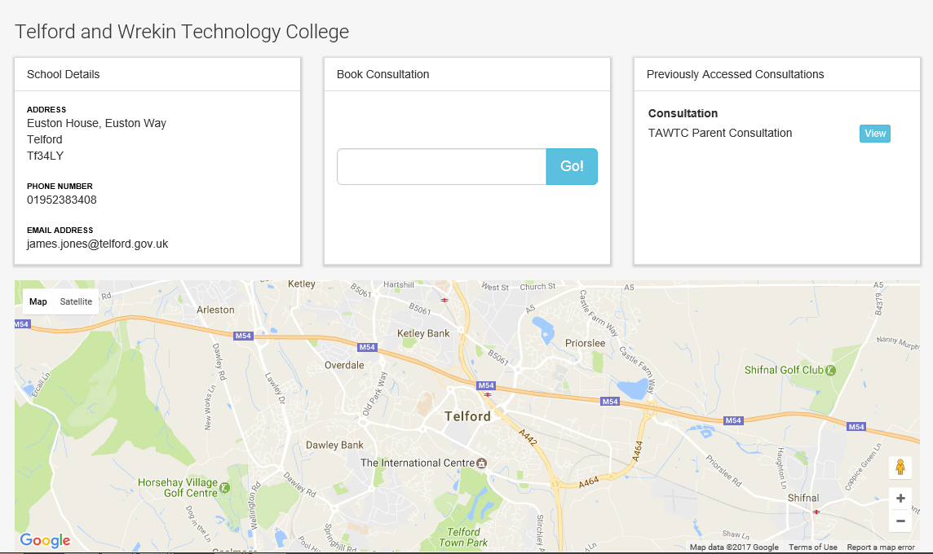
* From here you can wil need a “Consultation ID”. This will be a unique 5 digit number that is used to start booking spaces for your specific school. These will be communicated by the school and will be different for each Consultation hosted by the school.

*Booking a Consultation*

* After creating an account, registering your child and imputing the Consultation ID from your school you are ready to book an appointment.
* From here you will see a list of teachers, a number that indicates how many bookings are available and the teachers class/yeargroup/keystage under their name. On this page, please select the teacher you wish to visit.  
    
  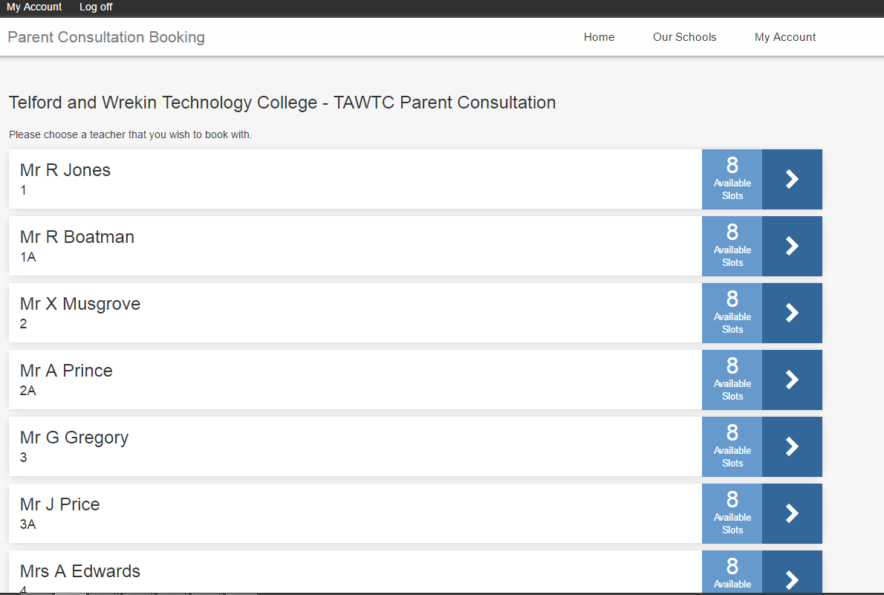

* Once you have done this you will be taken to the following page. While on this page please select a time and date that you wish to visit the teacher.  
    
  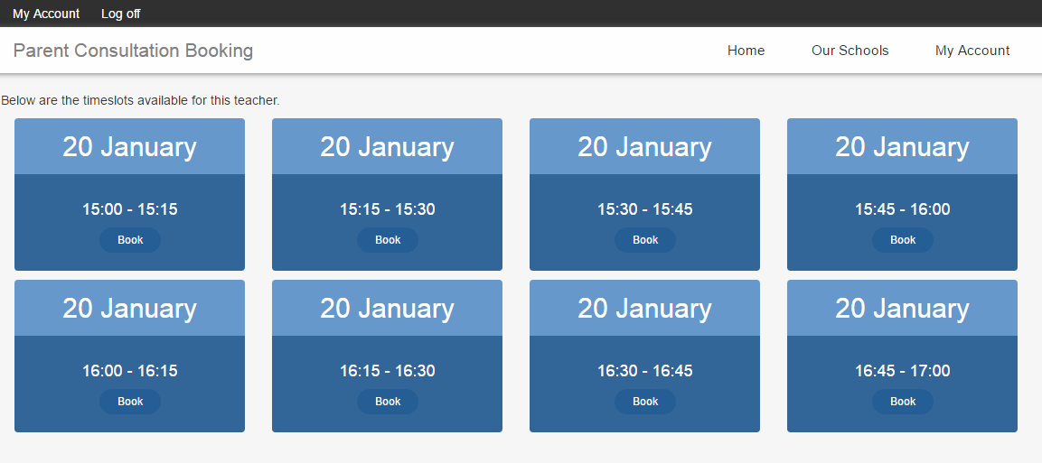
* After you have selected a date you will be able to select which child you would like to attend the session. After you are sure the date, time, teacher and child are correct click the arrow to confirm your booking.

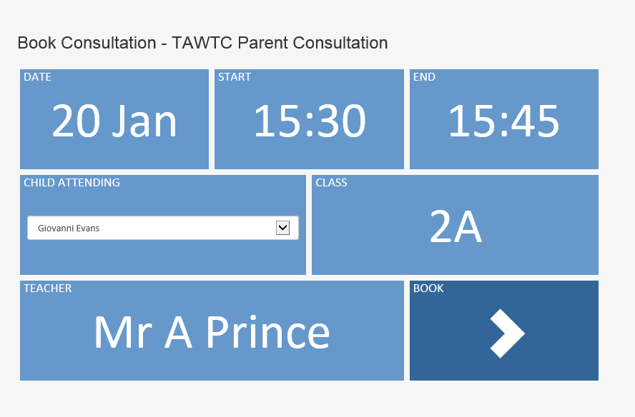

* Once this has been done you will be taken to a booking confirmation page.   
    
  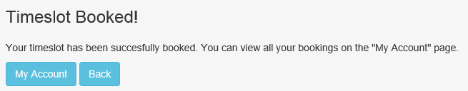
* If you click “My Account” you will be taken back to this page.   
    
  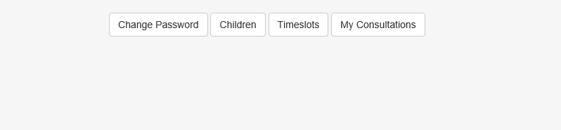
* By clicking timeslots you will be able to view the Booking you have made.  
     
  